This publication was produced by the Hunter Joint Organisation

Acknowledgements
This project has been funded by the New South Wales Government through the EPA’s Contaminated Land Management Program

Address for Correspondence:
Environment Division
Hunter Joint Organisation
PO Box 3137
THORNTON NSW 2322
Phone: (02) 4978 4020
Fax: (02) 4966 0588
Email: enviroadmin@huntercouncils.com.au
© Hunter Joint Organisation
Suggested Bibliographic Citation: Hunter Joint Organisation, 2020. Fuel System Operation Plan (FSOP) Guide. Hunter Joint Organisation.
Disclaimer
The development of this Guide: “Fuel System Operation Plan (FSOP)” has been developed by the Hunter Joint Organisation. The content of this Guide is current at the time of publication. While every effort has been made to ensure accuracy and completeness, no responsibility is taken, nor guarantee given, by the Hunter Joint Organisation with respect to errors or omissions in the materials contained in the Guide. The contents do not constitute legal advice, are not intended to be a substitute for legal advice, and should not be relied upon as such. The Hunter Joint Organisation does not accept any responsibility or liability in regard to the use of any information given in this Guide.

Fuel System Operation Plan

This Fuel System Operation Plan (FSOP) Guide contains the examples of the documented procedures and records required by the Protection of the Environment Operations (Underground Petroleum Storage Systems) Regulation 2019 (the UPSS Regulation), prepared under the Protection of the Environment Operations Act 1997 (the Act).

In accordance with Part 4, Clause 18 of the UPSS regulation, an underground petroleum storage system (UPSS) must not be used unless a Fuel System Operation Plan (FSOP) is in place at the site.

The UPSS Regulation requires the FSOP to contain the procedural documents and records specific to the UPSS. The FSOP must be kept on site so that practical written procedures are on hand to monitor the UPSS in order to detect leaks and spills and take appropriate action when they are identified.

How to use this Guide
This guide should be tailored by the UPSS’s Person Responsible to develop their own Fuel System Operation Plan.

[Advice and instructions are provided in highlighted text. It is intended that all highlighted text be removed from the final FSOP developed by the Responsible Person for the site, as they are intended for development purposes only.]

Should you require assistance in creating your own FSOP, contact your local Council.

Examples are provided in boxes for easy identification and differentiation from the contextual text. Examples demonstrate the level of detail desired to be found by Council as the Appropriate Regulatory Authority (ARA). As such, examples cannot be relied upon as being suitable to any particular site but should be used to inform the response from the Responsible Person.

The ‘HOW TO’ steps for completing the FUEL SYSTEM OPERATION PLAN (FSOP)

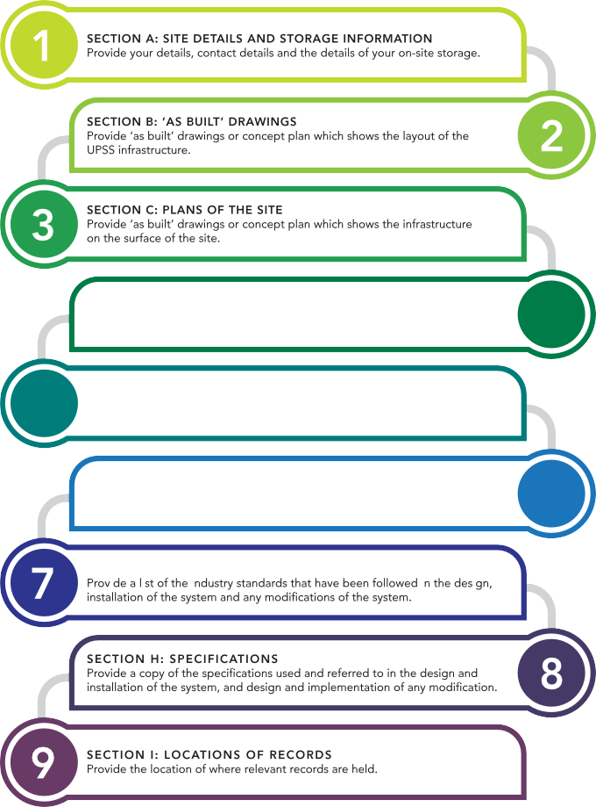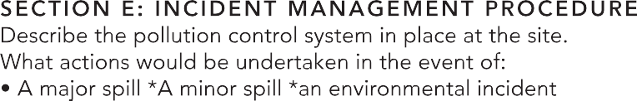

Fuel System Operation Plan

This Fuel System Operation Plan must be retained on site.

Revision number | Details/Amendments | Date | Amended By
1
2

Table of Contents
Section A – Site Details and Storage System Information 2
Storage System Information for UPSS 2
Section B - Current ‘as-built’ Drawings for the System 2
Section C - Plans of the Storage Site 2
Section D – Loss Monitoring Procedure 2
Detecting Loss From Underground Facilities 2
Section E - Incident Management Procedure 2
Incident Management Procedure 2
Section F – Maintenance Schedule 2
6-Monthly Groundwater Monitoring 2
Section G - Industry Standards 2
Section H - Specifications 2
Section I – Location of Records 2

Section A – Site Details and Storage System Information

Storage System Information for UPSS

Site name: [e.g. Corner Store Station]

Site address: [e.g. 117 Bull Street, Newcastle NSW 2300]

Land title particulars:
Lot Number: [e.g. 1]
DP Number: [e.g. 1234567]

Person responsible:
[Full name and job title]
If person responsible is a corporation, the name of a natural person who is authorised to act on behalf of the corporation.

Postal address (for person responsible or natural person – may differ from site address):
[e.g. PO Box 488G
Newcastle NSW 2300]

24-hour phone number (for person responsible or natural person):
[Name and 24-hr phone number]
[Additional contact point if applicable]

Name of site owner (if different from person responsible):
[Full name, contact number and business name if applicable]

Access and security information
[Details of access to, and security of, the system, including any locks, gates, fences, etc. and the means of opening them]
Details of on-site storage
[Your on-site storage details should be captured in a table, such as the table provided within the example below.]
Example (FOR GUIDANCE PURPOSES ONLY)
See below the details of the storage tanks present on The Site.
Tank I.D. | Fuel Type | Maximum Capacity (Litres) | Installation Date | Material Type
1 | ULP | 46,000 | 1980 | Steel
2 | PULP 95 | 29,500 | 2005 | Fibreglass
3 | PULP 98 | 30,500 | 2010 | Fibreglass with secondary containment

Section B - Current ‘as-built’ Drawings for the System

These are detailed site plans (to a recognisable scale) which depict the final installed configuration of any part of a UPSS and any construction deviations showing all features of the storage site as currently built. This does not include the pre-constructed drawings. The date of the plan should be included.

[Attach the most detailed and recent ‘As-built’ drawings available. ‘As-built’ drawings provide the ‘best approximation’ of the site]

[If the site owner is unable to locate ‘As-built’ drawings, then they must develop a site plan which provides a ‘best approximation’ of the site. This site plan must capture, as a minimum, the items provided within the example below]
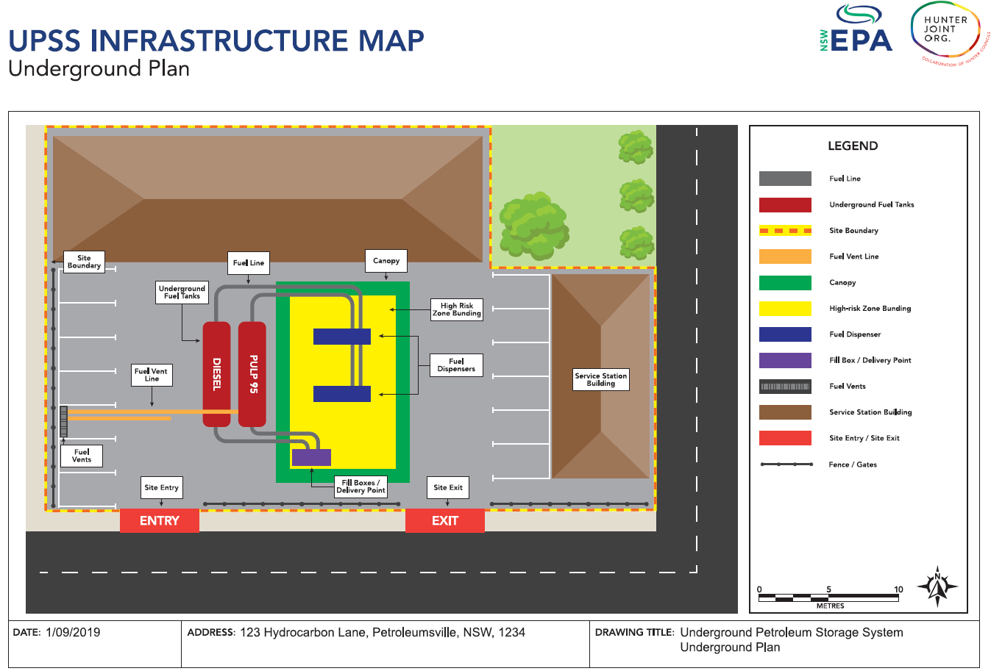

Section C - Plans of the Storage Site

This plan should show the locations of each of the following:
- the storage system
- all buildings and associated infrastructure
- all fences and gates
- all groundwater monitoring wells (including any codes by which they are designated)
- any unsealed ground surfaces.

[Attach the most detailed and recent ‘Storage Site’ drawings available. ‘Storage Site’ drawings provide the ‘best approximation’ of the site]

[If the site owner is unable to located the ‘Storage site’ drawings, then they must develop a site plan which provides the ‘best approximation’ of the site. This site plan must capture, as a minimum, the items within the example below.]
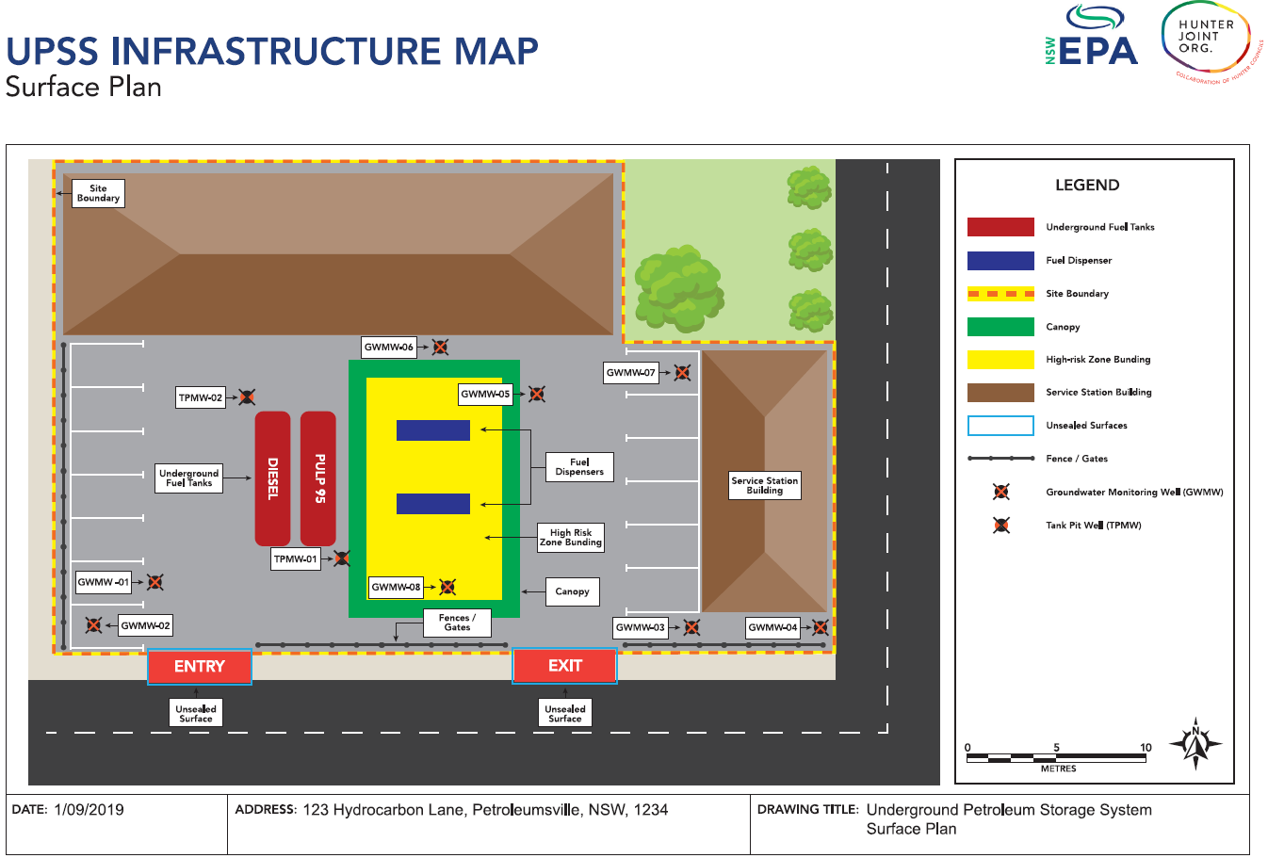

Section D – Loss Monitoring Procedure

The loss monitoring system must be designed to detect losses of petroleum by measuring discrepancies between

- the amount of petroleum that should be in the system, and
- the amount of petroleum that is actually present in the system.

Statistical Inventory Reconciliation Analysis (SIRA) is an example of a loss monitoring system.

Detecting Loss From Underground Facilities

Loss monitoring procedures are designed to detect any losses of petroleum from UPSS tanks or piping before they pollute the soil, surface waters or groundwater. The frequency, sensitivity and reliability of loss monitoring should lead to a high level of confidence that any potential product loss will be detected in time to allow a response before a risk is posed to human health or the environment.

The following protocol is currently used by [SITE NAME] to assess loss from underground storage systems:

- [Measure in place to detect loss for inventory analysis;
e.g. Calibrated Dipstick OR Automatic Tank Gauging (ATG) OR both]

- [Measure in place to calculate inventory loss;
e.g. Statistical Inventory Reconciliation Analysis (SIRA) system which meets the standard requirements of AS4897–2008 (AS 2008a) or an equivalent standard in terms of protection of human health and the environment]

- [The process by which results of inventory loss calculations are obtained]

- [The methodology in place to identify whether loss of product is due to leakage or other factors.]

[OPTIONAL: Insert supporting flow-chart to visualize the above methodology]

Example Loss Monitoring Procedure (FOR GUIDANCE PURPOSES ONLY)
The following protocol is currently used by The Site to assess product volumes:
- Automatic Tank Gauging (ATG) is utilised to check the fuel volume and water status. The ATG is also used to record the fuel volume status before and after deliveries. The franchisees are trained in how to use the ATG and as well as how to conduct manual dipping, with the training records kept at the on-site office.
- Gauging data is relayed electronically to The Site’s third-party provider. Tanks are also dipped once a week manually to verify data and check for water.
- The Site’s third-party provider analyses the data and advises The Site of Pass, Inconclusive or Fail results based on 0.76 litres per hour tolerance as per US EPA Standards as adopted by the NSW EPA.
- If the results obtained are below the accepted trigger levels then no further action is taken. If the results exceed the trigger levels, then a thorough check of data integrity is undertaken. Should no errors be encountered, then the following activities may be completed:
  - Check calibration of dispensers;
  - Check supply volumes; check supply conditions (loss may have occurred due to temperature variations);
  - The secondary contained underground storage tanks (USTs) shall have the interstitial space checked or tested;
  - The secondary contained piping systems shall have the interstitial space checked or tested;
  - Tank pit observation wells are checked (visual observation);
  - Groundwater monitoring wells are checked (visual observation).
A duly qualified person would carry out the on-site checks.
If the works fail to identify any site errors, then Equipment Integrity Testing (EIT) of suspect lines and tanks is undertaken. Line and tank integrity testing is also completed if on-going water or sand is observed in the fuel or fuel tanks.
The SIRA system is 3rd party accredited, recommended by the NSW EPA and complies with relevant guidelines.

Section E - Incident Management Procedure
The incident management procedure must set out the steps to be followed when dealing with any leaks and spills of petroleum from the underground petroleum storage system.

Incident Management Procedure
Any event which occurs outside of the normal operation and maintenance of a fuel storage and dispensing system is defined as an emergency. Such events may result in a loss of containment of fuel product.
A loss of containment will allow petroleum products to escape the storage and dispensing system to create a potentially dangerous situation which will require immediate action to reduce the impact and maintain the safety of the site and surrounding environment.
All incidents relating to petroleum product being released to the environment are to be reported to 24/7 Support and an incident report form is to be completed immediately.
An incident management procedure should detail the following items:
- Pollution Control System: The system, composed of a series of physical measures, which captures on-site pollution and reduces the potential impact to safety and environment. [An example Pollution Control System is provided on page 20, this is for guidance purposes only. You must identify and describe your site-specific features and risks when developing your Pollution Control System.]
- Minor Spills: The series of actions which are to be undertaken in the event that there is a spill involving a small volume (Less than or equal to 5 Litres) of product. [An example Minor Spills Response Plan is provided on page 21, guidance purposes only. You must identify and address your site-specific features and risks when developing your Minor Spill Response Plan.]
- Major Spills: The series of actions which are to be undertaken in the event that there is a spill involving a large volume (greater than 5 Litres) of product. [An example Major Spills Response Plan is provided on page 21, for guidance purposes only. You must identify and address your site-specific features and risks when developing your Major Spill Response Plan.]
- Environmental Incidents: The series of actions which to be undertaken in the event that there is a spill which may contact the surrounding environment. [An example Environmental Incident Response Plan is provided on page 22, for guidance purposes only. You must identify and address your site-specific features and risks when developing your Environmental Incident Response Plan.]
- Other incidents, as identified by the Responsible person, e.g. Evacuation, Robbery, Assault, Fire/Explosion, Motor Vehicle Accident, Bomb Threat, etc. [You must identify and address your site-specific features and risks when developing your Other Incident Response Plan.]
Consideration must be given to the process undertaken both during and after an emergency event occurs.

NOTE: It is the Responsible Person’s responsibility to ensure the accuracy and completeness of their incident management procedure. The content within the examples below are intended to provide guidance and do not constitute a site-specific incident management procedure, and should not be relied upon as such. It is the Responsible Person’s responsibility to identify the risks which are unique to their site in order to develop a site-specific incident management procedure and manage their identified risks.

Example 1. Pollution Control System (FOR GUIDANCE PURPOSES ONLY)
The following example of a pollution control system is intended as guidance only. The nominated responsible person should describe a pollution control system based upon their site-specific conditions.
- Pollution Control System:
The Site has an installed forecourt pollution control system. This system comprises:
    - A canopy over the fuel dispensing area with a 10-degree overhang
    - Impervious forecourt surface
    - Heavy duty impact bollards to protect bowsers
    - Spill containment boxes around filling points
    - Spill containment sumps under bowsers
    - Bunding around fuel dispensing area
    - Graded surface to divert clean stormwater away from the high-risk fuel dispensing area
    - Interception pits
    - An oil water separator with a 9000 L capacity
    - Spill kit
    - Stage 1 and Stage 2 vapour recovery
This system is regularly monitored and maintained to ensure minor spills are contained and to limit the potential for environmental discharges.

Example 2. Minor and 3. Major Spill Response (FOR GUIDANCE PURPOSES ONLY)
2. Minor Spill (Less than or Equal to 5 Litres) | 3. Major Spill (Greater than 5 Litres)
- Press the ‘EMERGENCY STOP ALL PUMPS’ button on the console control | - Press the ‘EMERGENCY STOP ALL PUMPS’ button on the POS  Turn Mains Power off at the switchboard
- Use Public Address System (loud speaker) to ask customers NOT to start their cars | - Call Emergency Services 000 – Fire Brigade
- Put on safety vest and safety gloves  Cordon off the area using safety cones and the Spill Kit Bin  Keep people, vehicles and all sources of ignition away from the area – at least 15 metres where possible | - Put on safety vest, cordon off the area using safety cones and the Spill Kit Bin  Keep people, vehicles and all sources of ignition away from the area – at least 15 metres where possible
- Isolate source of leak if possible  Prevent spill from spreading and entering drains by using the equipment in the Spill Kit Bin to block the entrance to drains  Absorb the spill with the contents from the Spill Kit Bin  Ensure spill area has been completely cleaned and is safe before allowing public access to the area | - Evacuate all people and customers from the site and advise them to assemble at the Evacuation Assembly Area
- Place the used spill kit material into the red bin, away from sources of ignition | - Eliminate possible sources of ignition
- Call 24/7 Support 1800 655 160 to arrange for the collection and disposal of the used spill kit contents – an EPA certificate must be supplied by the waste contractor and filed in store | - Prevent fuel from spreading and entering drains by using the equipment in the Spill Kit Bin to block the entrance to drains
- Complete Spill Kit log | - Place the used spill kit material into the red bin, away from sources of ignition
 | - Call 24-7 Support 1800 655 160 to arrange for the collection and disposal of the used spill kit contents – an EPA certificate must be supplied by the waste contractor and filed in store
 | - Complete Spill Kit log

Example 4. Environmental Incident Response Plan (FOR GUIDANCE PURPOSES ONLY)
- Environmental Incident
In the event of a spill, tank leak or underground petroleum release that may result in discharge to the surrounding environment (i.e. stormwater, surface water or groundwater) the above procedure for major spill is to be followed and the area is to be made safe.
Part 5.7 of the Act requires the occupier of premises, the employer or any person carrying on the activity which causes a pollution incident to immediately notify each relevant authority (identified below) when material harm to the environment is caused or threatened.
The following procedure is to be followed for reporting a pollution incident:
Firstly, call 000 if the incident presents an immediate threat to human health or property. Fire and Rescue NSW, the NSW Police and the NSW Ambulance Service are the first responders, as they are responsible for controlling and containing incidents.
If the incident does not require an initial combat agency, or once the 000 call has been made, notify the relevant authorities in the following order:
- Council as the Appropriate Regulatory Authority (ARA) on 02 4993 4100
- The EPA Environment Line on 131 555
- The Ministry of Health via the local Public Health Unit, see
www.health.nsw.gov.au/publichealth/infectious/phus.asp
- NSW SafeWork – phone 13 10 50
Under Section 150 of the Act, relevant information about a pollution incident consists of the following:
- the time, date, nature, duration and location of the incident,
- the location where pollution is occurring or is likely to occur,
- the nature, the estimated quantity or volume and the concentration of any pollutants involved, if known,
- the circumstances in which the incident occurred (including the cause of the incident, if known),
- the action taken or proposed to be taken to deal with the incident and any resulting pollution or threatened pollution, if known.
- Complete a Leak Notification Form, see
http://www.environment.nsw.gov.au/upss.htm
- Arrange for maintenance contractor and UPSS integrity contractor to attend site to rectify the situation.
- Arrange for environmental consultant to attend site to assess incident and work in consultation with government officer to rectify / remediate the incident.

Section F – Maintenance Schedule
The FSOP shall include the details of the on-site maintenance which is scheduled to be carried out and when it is scheduled, in relation to the system generally and in relation to the various gauges, indicators, groundwater monitoring wells and other measuring instruments which form part of the system in order to comply with relevant State and National legislative and regulatory requirements. This includes a detailed procedure on the groundwater monitoring plan in place at the site.
All Certification, Compliance Documentation and routine maintenance records are to be retained at a nominated office and accessible upon request.
The maintenance schedule is to be in accordance with the required relevant industry standards.
The FSOP shall also include the details of the on-site storage tanks.
[An example of a UPSS Maintenance Schedule is provided on page 24, for guidance purposes only. You must identify and address your site-specific features, risks and equipment when developing your UPSS Maintenance Schedule.]
NOTE: It is the Responsible Person’s responsibility to ensure the accuracy and completeness of their UPSS Maintenance Schedule. The content within the examples below are intended to provide guidance and do not constitute a site-specific UPSS Maintenance Schedule, and should not be relied upon as such. It is the Responsible Person’s responsibility to identify the equipment on their site in order to develop a site-specific UPSS Maintenance Schedule and manage their identified equipment.

Example UPSS Maintenance Schedule (FOR GUIDANCE PURPOSES ONLY)
See below a maintenance scheduling table for The Site.
Item | Schedule | Responsibility | Contractor
Cleaning and degreasing of dispensers | Weekly
Fuel pump hoses, fittings and pumps | 6 Monthly
Fuel pump/dispenser calibrations | 12 monthly
Fuel pump/dispenser certifications | 2 Yearly
Leak detectors on pressure systems | 12 Monthly
Water tests all fuel grades | Weekly
Water tests ethanol grades | Daily
Dip stick inspection (end damage) | Weekly
Grated drains and pits - pumping | 3 Monthly
Oil/water separators and interceptor pits | 6 Monthly
Inventory reconciliation | Daily
Tank & line integrity tests | SIR event
Groundwater and tank pit monitoring wells | 6 monthly

6-Monthly Groundwater Monitoring
The Regulation requires that groundwater monitoring events be undertaken on a 6-monthly basis.
[Provide a description of the groundwater monitoring program being implemented at site]
An example of a 6-Monthly Groundwater Monitoring Procedure is provided below, for guidance purposes only. You must identify and address your site-specific features, risks and equipment when developing your 6-Monthly Groundwater Monitoring Procedure.

Example 6-Monthly Groundwater Monitoring Procedure (FOR GUIDANCE PURPOSES ONLY)

The Site undertakes groundwater monitoring testing on a 6-month basis, and the groundwater testing records are completed and held both on-site in hardcopy and remotely. The testing on-site involves an initial visual test to observe any potential sheen, which indicates hydrocarbon contamination. After the visual test is undertaken, an interface probe is used to detect phase separated hydrocarbons (PSH). If PSH are detected, or a visual sheen observed, as part of the groundwater monitoring program, within 30 days, all wells are sampled and sent to a laboratory for further analysis to determine the total amount of potential contaminants (Petroleum Hydrocarbons, Benzene, Toluene, Ethyl-Benzene and Xylenes (BTEX), Poly Aromatic Hydrocarbons (PAHs) and Lead).

If neither a visual sheen nor PSH are detected then all existing wells on the storage site will continue to be monitored on a six-monthly basis as per The Regulation.

If contamination has been identified onsite or is likely to be migrating offsite, the leak will be treated as an emergency in accordance with the Incident Management Procedure and the Appropriate Regulatory Authority (ARA) will be notified.

Groundwater monitoring records and all corresponding reports are retained at [Location] and can accessed upon request submitted to [Contact Detail].
[Attach an ‘As-built’ plan or map showing the installed ground-water monitoring wells]

Groundwater monitoring records and all corresponding reports are retained at [Location] and can accessed upon request submitted to [Contact Detail].
[Attach an ‘As-built’ plan or map showing the installed ground-water monitoring wells, such as that found on page 26]

Example Groundwater Monitoring Well Layout Map
See below an example of a generalised map layout plan indicating the location of existing Groundwater Monitoring Wells.
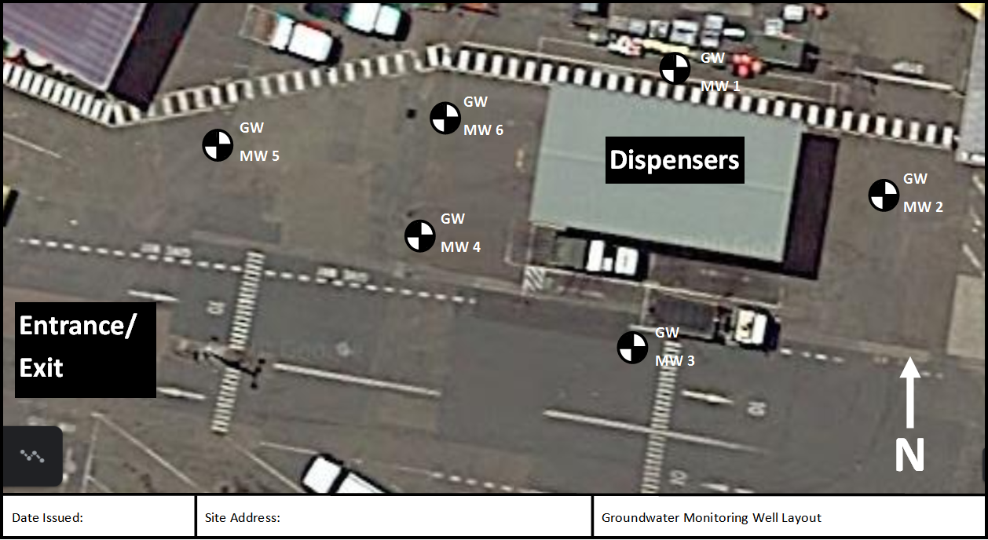

Section G - Industry Standards

A copy of each list of industry standards that have been followed in connection with each of the following:

- The design of the system
- The installation of the system
- The design of any modification

OR

The implementation of any modification or In the absence of a list of industry standards, documented evidence that the person responsible for the system has taken all reasonable steps to obtain such a list.

[An example of an Industry Standards List is provided on page 28, for guidance purposes only. You must identify Industry Standards which are relevant to your site when developing your Industry Standards List.

Example Industry Standards List (FOR GUIDANCE PURPOSES ONLY)
The following list of Standards were applied for all existing works, and will be applied for all future works. The list will be reviewed prior to any site modification to ensure currency is maintained.
DESCRIPTION | STANDARD
The Design Installation and Operation of  Underground Petroleum Storage Systems | AS 4897 – 2008
Pipelines – Gas and Liquid Petroleum – General Requirements | AS 2885.0 - 2008
Pipelines – Gas and Liquid Petroleum – Design and Construction | AS 2885.1 - 2012
Pipelines – Gas and Liquid Petroleum – Operation and Maintenance | AS 2885.2 - 2016
The Control of Undesirable Static Electricity | AS /NZS 1020 - 1995
The Storage and Handling of Flammable Combustible Liquids | AS 1940 - 2017
Steel Tanks for Flammable and Combustible Liquids | AS 1692 - 2006
The Removal and Disposal of Underground Petroleum Storage Tanks | AS 4976 - 2008
Petroleum Products – Pipeline, Road, Tanker Compartment and Underground Tank Identification | AS 4977 - 2008
Classification of Hazardous Areas | AS 2430
Installation of Groundwater Monitoring Wells and Groundwater Monitoring | Minimum Construction Requirements for Water Bores in Australia, 3rd Edition, February 2012.
 | Guidelines for Consultants Reporting on Contaminated Sites, NSW OEH, 2011 (first published NSW EPA 1997)
 | Guidelines for Implementing the Protection of the Environment Operations (Underground Petroleum Storage Systems) Regulation 2008, NSW DECCW 2009.
 | Australian Water Quality Guidelines for Fresh and Marine Waters, ANZECC 2000.
Tank Decommissioning and Validation | UPSS Technical Note: Decommissioning, Abandonment and Removal of UPSS, NSW DECCW 2010.
 | UPSS Technical Note: Site Validation Reporting, NSW DECCW 2010.
Guidelines for Consultants Reporting on Contaminated Sites, NSW OEH, 2011 (first
published NSW EPA 1997).

Section H - Specifications

A copy of all specifications used and referred to, including:
- The design specifications for the system;
- The installation specifications for the system;
- The design specifications for any modification; and
- The implementation specifications for any modification.
OR
In the absence of a copy of specifications, documented evidence that the person responsible for the system has taken all reasonable steps to obtain such copies.
[Either demonstrate that copies of all relevant specifications have been obtained and are accessible OR attach a letter of support which includes;
- The specifications used
- Certification with The Protection of the Environment Operations (Underground Petroleum Storage Systems) Regulation 2019]

Section I – Location of Records

Records kept in accordance with Part 5 and Part 6 of the Regulation, especially specifics of any off-site storage of records.

The records associated with any significant modification made to the storage system are held at:
[Insert the location of records, on-site or at alternate office location. Records must be accessible upon request e.g. Records are located within the store on site and available upon request]
This includes the following;
A comprehensive description of the modification
The dates of comment and completion of the modification
The results of the equipment integrity test carried out
Current “as-built” drawings for the system, revised to reflect the modification

An incident log is held at:
[Insert the location of records, on-site or at alternate office location. Records must be accessible upon request e.g. Records are located within the store on site and available upon request]
This includes the following;
- The carrying out of an activity, by a person acting otherwise than at the direction or request of a person responsible for the system, that has affected, is affecting or could affect the integrity of the system
- The occurrence of any unplanned or abnormal incident (including operational disruptions or equipment failures) that has affected, is affecting or could affect the long-term safety of the system.

Any documents which are required to be kept for seven years, from the date of creation, are held at:
[Insert the location of records, on-site or at alternate office location. Records must be accessible upon request e.g. Records are located within the store on site and available upon request]
This includes the following;
- The results of any equipment integrity tests
- Data produced by any measuring equipment (this includes leak detection and loss monitoring systems)
- Details of any action undertaken as part of loss detection procedures
- Any documents prepared as part of system decommissioning
- Any notifications made as part of pollution incident reporting
- Anything required under the Protection of the Environment Operations (Underground Petroleum Storage Systems) Regulation 2019

Any documents which are required to be kept for seven years from date of decommissioning are held at:
[Insert the location of records, on-site or at alternate office location. Records must be accessible upon request e.g. Records are located within the store on site and available upon request]
This includes the following;
- Each certificate issued for the system regarding Equipment Integrity Testing
- A leak detection system report
- Each version of the Fuel System Operation Plan
- A record made in relation to significant modifications
- A report made in relation to the decommissioning or tank removal and/or replacement
- The incident report kept for the system
- Any report that has been in relation to a pollution incident
- Anything required to be documented under Protection of the Environment Operations (Underground Petroleum Storage Systems) Regulation 2019 immediately before its repeal.

NOTE:
Within 30 days after there is a change in responsibility for a storage system, the person responsible for the system before the change must ensure that all documents for the system that this Part requires to be kept, and that are in the person’s possession, are delivered to the person newly responsible for the system.

